33.45: 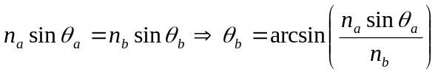
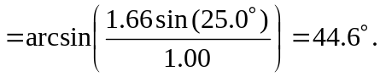
So the angle below the horizontal is 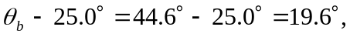and thus the angle between the two emerging beams is 